**Client: Scalawags Veterinary Clinic**



**Kevin Yang**

**John Beguhl**

**Zuhair Rauf**

**Yannan Zhu**

**Jisung Woo**

**Scalawags Veterinary Clinic**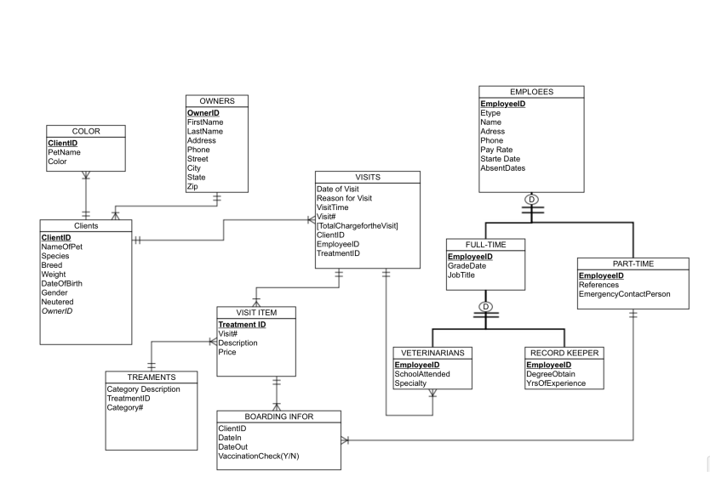

**Database Schema**

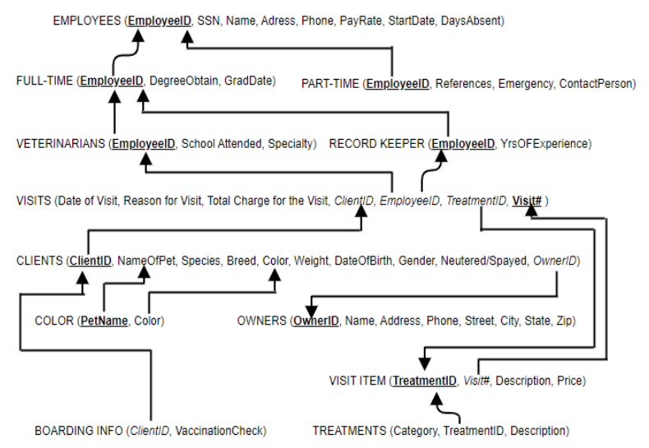

**Test Queries Screenshot**

* Employees

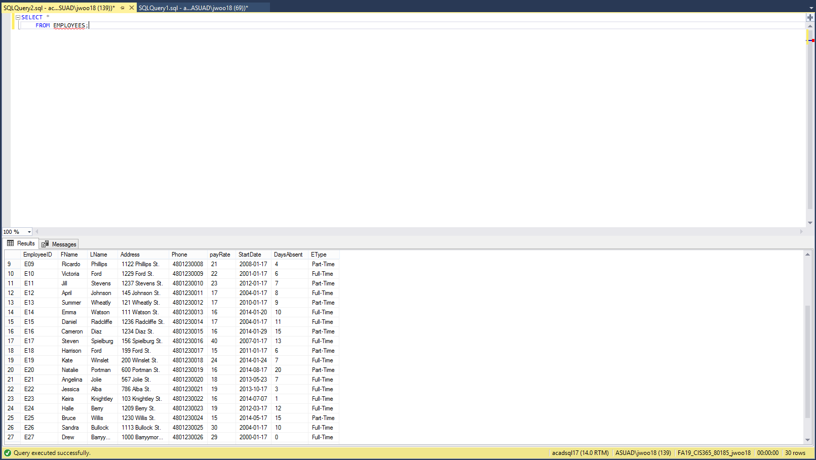

* Full Time

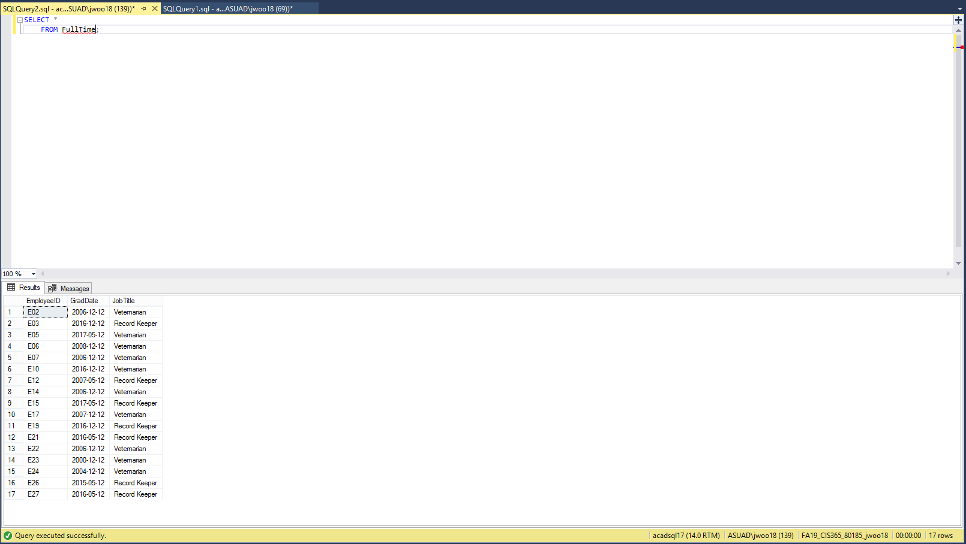

* Part Time

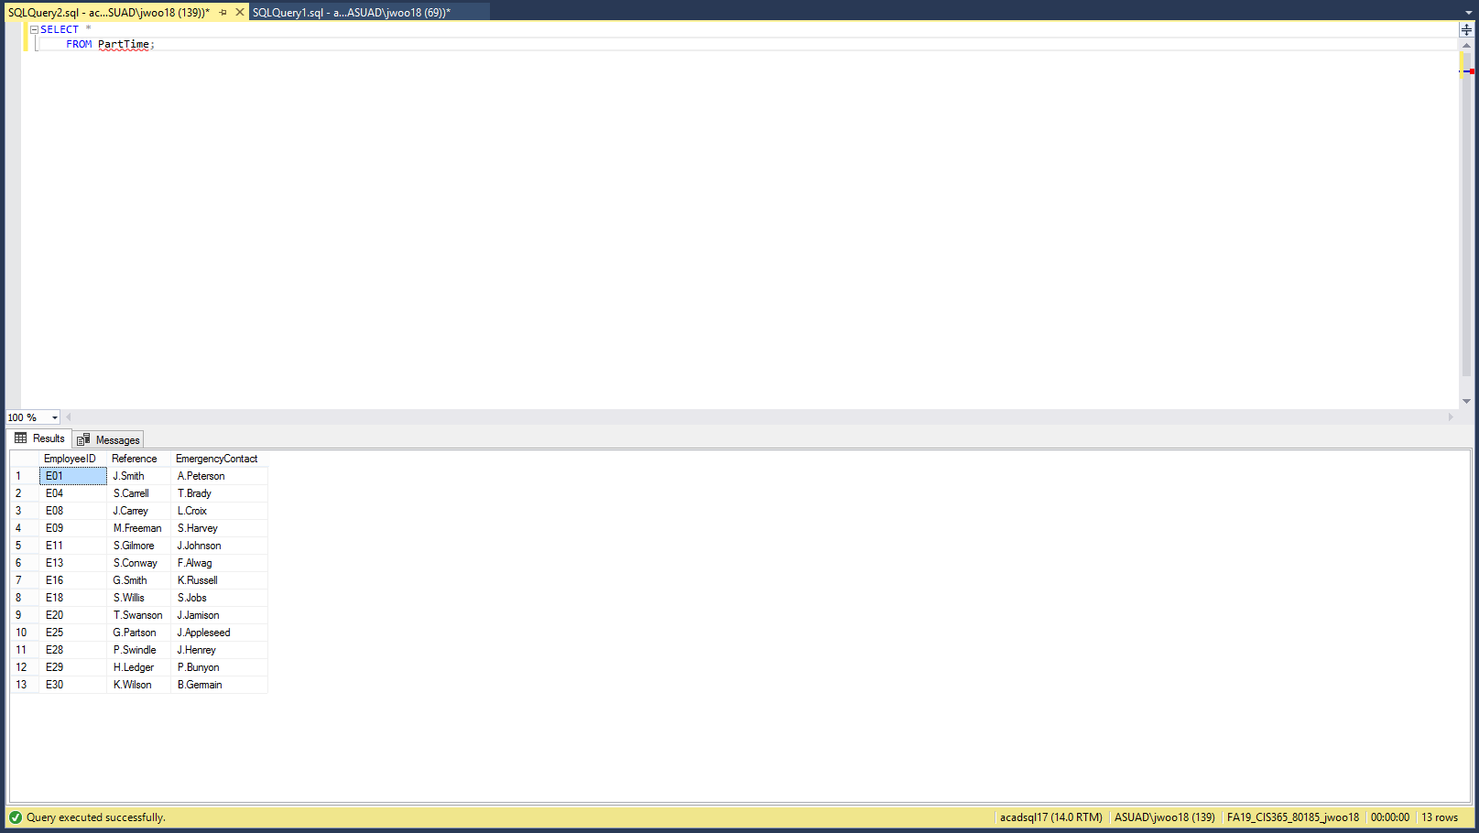

* Veterinarians

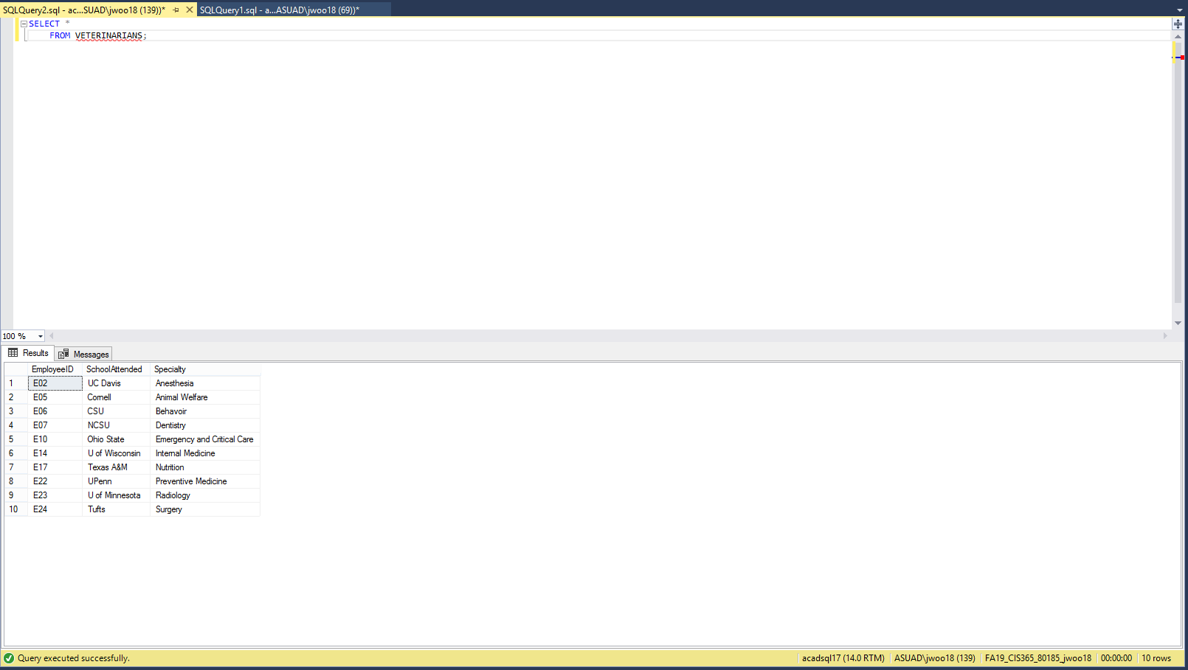

* Record Keeper

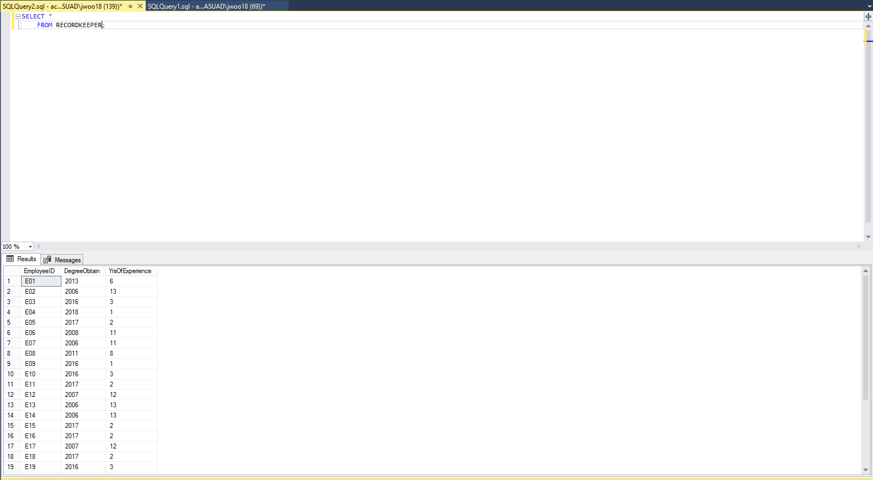

* Owners

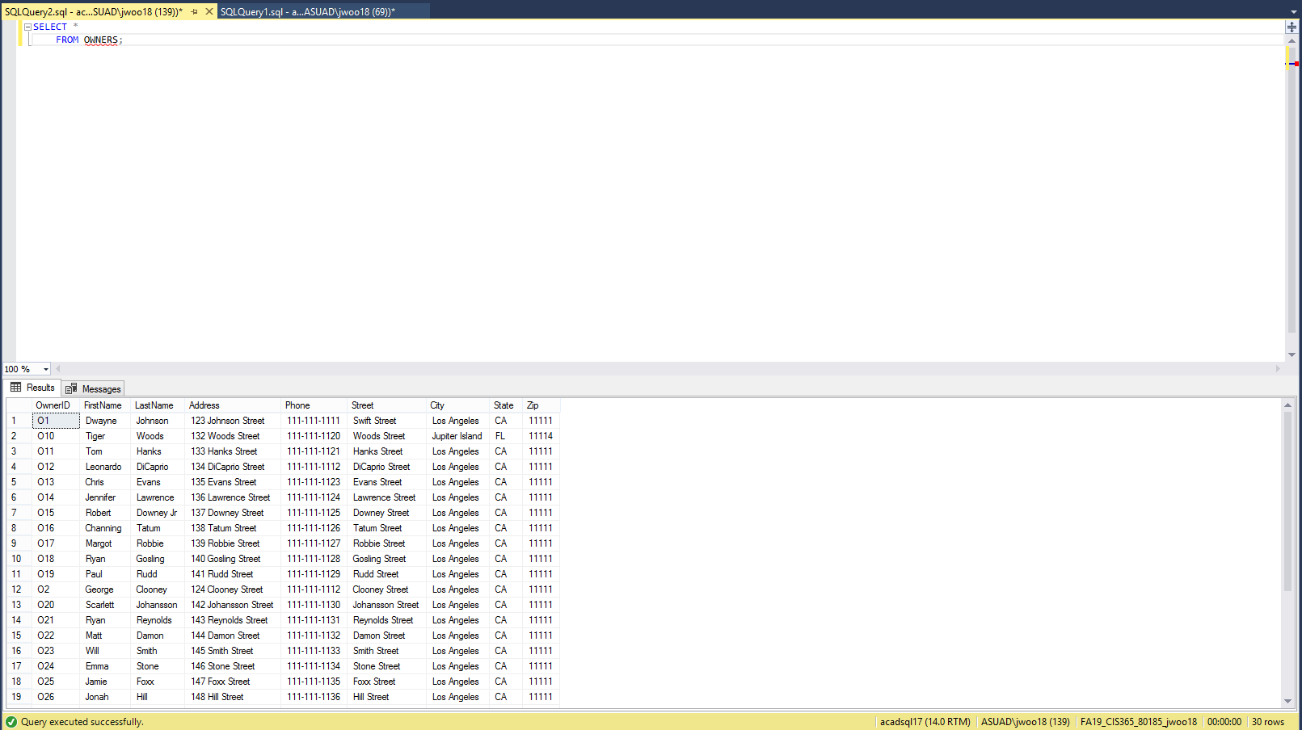

**Individual Journal Entry**

|  |  |  |
| --- | --- | --- |
| ***Team Member Name: Kevin Yang*** | | |
| ***Date of Work Performed*** | ***Description work performed*** | ***Time Spent on Work Performed (HRS)*** |
| 9/6 2019 | Answered team questionaire for member introduction | 1 |
| 9/10 2019 | Team meeting | 0.25 |
| 9/11 2019 | Write introduction for myself | 1 |
| 9/12 2019 | Team logo development (image editing) | 0.2 |
| 9/14 2019 | Update team profile | 0.1 |
| 9/14 2019 | Upload resume to team google doc | 0.2 |
| 9/14 2019 | Upload headshot to team google doc | 0.7 |
| 9/14 2019 | Update histogram | 0.1 |
| 9/14 2019 | Upload group availabilty schedule to team google doc | 0.2 |
| 9/14 2019 | Update assigned tasks on team google doc | 0.3 |
| 9/15 2019 | Create chart for team histogram | 0.5 |
| 9/15 2019 | Put initial on pages worked on | 0.25 |
| 9/15 2019 | Upload Journal Entry to team google doc | 0.1 |
| 9/15 2019 | Check font and formatting on document | 0.1 |
|  | Total Hours(9/6 ~ 9/15): | 5 |
| 9/18 2019 | Team Meeting | 0.25 |
| 9/23 2019 | Team Meeting | 1.1 |
| 9/25 2019 | Office Hour (ERD) | 1 |
| 9/25 2019 | Team Meeting | 0.5 |
| 9/28 2019 | Recreate Team Histogram | 0.167 |
| 9/28 2019 | Update Histogram | 0.167 |
| 9/28 2019 | Data dictionary definiton | 1 |
| 9/29 2019 | Update Histogram | 0.05 |
| 9/29 2019 | Upload Journal Entry to team google doc | 0.05 |
|  | Total Hours (9/18 ~ 9/29): | 4.284 |
| 10/2 2019 | Office Hour | 1 |
| 10/22 2019 | Create data for Scalawag | 1.42 |
| 10/26 2019 | Draw Data Schema | 0.09 |
| 10/26 2019 | Write Data script | 2 |
| 10/27 2019 | Upload Data script | 0.017 |
| 10/27 2019 | Draw Data Schema | 1 |
| 10/27 2019 | Data Script Revision | 0.6 |
| 10/27/ 2019 | PDF submission file formatting | 0.083 |
|  | Total Hours (10/2 ~ 10/27): | 6.21 |

**Individual Journal Entries**

|  |  |  |
| --- | --- | --- |
| ***Team Member Name: John Beguhl*** | | |
| ***Date of Work Performed*** | ***Description work performed*** | ***Time Spent on Work Performed (HRS)*** |
| 9/8/2019 | Filled out questionaire for team intros | 0.5 |
| 9/8/2019 | Wrote introduction for Zu | 0.45 |
| 9/10/2019 | Had a team meeting on next steps for Milestone 1 | 0.25 |
| 9/12/2019 | Updated resume | 0.6 |
| 9/12/2019 | uploaded resume to Milestone 1 with headshot | 0.15 |
| 9/12/2019 | Drafted team Charter | 0.85 |
| 9/12/2019 | Edited formating of Milestone 1 and provided feedback on logo | 0.25 |
| 9/12/2019 | Updated histogram | 0.1 |
| 9/12/2019 | Updated Meeting Agneda | 0.15 |
| 9/13/2019 | Created site to find meeting times | 0.2 |
| 9/15/2019 | Updated histogram | 0.1 |
| 9/15/2019 | Proofread Documents and intitialed documents and uploaded journal entry | 0.4 |
| 9/18/2019 | Team Meeting - discussing how to approach Milestone 2 | 0.5 |
| 9/20/2019 | Read business rules for client | 0.5 |
| 9/23/2019 | Team Meeting- Worked on EERD | 1.3 |
| 9/24/2019 | Client EERD | 0.5 |
| 9/25/2019 | TeamMeeting - Finalized the EERD | 0.5 |
| 9/28/2019 | Worked on the Data Dictionary | 0.3 |
| 9/29/2019 | Update journal entries and histogram. Proofread document and Submitted assignment | 1 |
| 10/2/2019 | Worked on Fixing ERD | 0.3 |
| 10/16/2019 | Generating Data For the database | 2 |
| 10/16/2019 | Updating Data Dictionary | 0.5 |
| 10/19/2019 | Start Writing Script | 0.5 |
| 10/27/2019 | Creating Tables in SQL and formatting and ordering Scripts | 2 |
|  | Total | 13.9 |

**Individual Journal Entries**

|  |  |  |
| --- | --- | --- |
| ***Team Member Name: Jisung Woo*** | | |
| ***Date of Work Performed*** | ***Description work performed*** | ***Time Spent on Work Performed (HRS)*** |
| 8/29/2019 | Gathered Team's information | 0.2 |
| 8/29/2019 | Created Milestone 1 Google Drive Folder and Document | 0.1 |
| 9/7/2019 | Answered 15 questions from "100 getting to know you questions" | 1 |
| 9/8/2019 | Wrote Yannan Zhu's introduction | 1 |
| 9/10/2019 | Had a team meeting (arrived late) | 0.17 |
| 9/10/2019 | Created Title Page and researched for suitable logo | 0.5 |
| 9/10/2019 | Created multiple documents, Agenda, Individual Journal Entries, Logo ideas, and resource Histogram | 2 |
| 9/11/2019 | Declared for chair position | 0.02 |
| 9/11/2019 | Edited Meeting Agenda for both 8/29/2019 and 9/10/2019 | 1.5 |
| 9/11/2019 | Updated and uploaded my resume and pictures | 0.75 |
| 9/11/2019 | Edited Team Profile section on Milestone one | 0.25 |
| 9/11/2019 | Updated Resource Histogram | 0.1 |
| 9/12/2019 | Reviewed and Signed Team Agreement | 0.2 |
| 9/13/2019 | Complete "when to meet" website | 0.083 |
| 9/14/2019 | Finalized Meeting Agendas | 0.5 |
| 9/14/2019 | Made sure if all documents were in correct format and correct font | 0.05 |
| 9/14/2019 | Added consequences section on Team Agreement document | 0.17 |
| 9/15/2019 | Finished "Assigned Tasks" section on Milestone 1 | 0.017 |
| 9/15/2019 | Wrote my initials on the pages that I've created and/or worked on | 0.17 |
| 9/15/2019 | Gave team warning on what is still missing from certain people and need in better communication | 0.17 |
| 9/18/2019 | Team Meeting | 0.5 |
| 9/18/2019 | Re-create Individual Journal Entries | 0.083 |
| 9/18/2019 | Re-create Unedited Version of Meeting Agenda | 0.083 |
| 9/21/2019 | Milestone 2 Outline on my own | 0.5 |
| 9/23/2019 | Team Meeting | 1.25 |
| 9/23/2019 | Created and edited "Questions for Office Hour/Tutoring Center" | 0.167 |
| 9/24/2019 | Create my own draft of EERD | 0.5 |
| 9/25/2019 | Create a separate document and upload EERD (because I won't be able to attend the meeting) | 0.083 |
| 9/27/2019 | Created data dictionary and worked on it | 0.75 |
| 9/28/2019 | Slightly edited Data Dictionary | 0.167 |
| 9/28/2019 | Fixed minor issues from the team meeting document | 0.0167 |
| 9/28/2019 | Edited on Team16-M2 | 0.167 |
| 9/29/2019 | Updated and uploaded Individual Journal Entries and Resource Histogram | 0.1 |
| 9/29/2019 | Proofread the document | 0.05 |
| 10/16/2019 | Created and worked on Data of Client and children of Employee | 1 |
| 10/22/2019 | Continued and finished working on data | 1.5 |
| 10/22/2019 | Started writing Client and children of Employee Schema | 0.5 |
| 10/24/2019 | Write the scripts | 2 |

**Individual Journal Entries**

|  |  |  |
| --- | --- | --- |
| ***Team Member Name: Yannan Zhu*** | | |
| ***Date of Work Performed*** | ***Description work performed*** | ***Time Spent on Work Performed (HRS)*** |
| 9/8/2019 | Answered 15 questions about myself | 1 |
| 9/8/2019 | Wrote Jisung's introduction | 1 |
| 9/14/2019 | Upload the resume | 0.5 |
| 9/14/2019 | Upload the headshot | 0.5 |
| 9/14/2019 | Update histogram | 0.4 |
| 9/14/2019 | Update Agenda | 0.2 |
| 9/15/2016 | Updated assigned tasks and journal entries | 0.2 |
|  | Total hours(9/8 - 9/15): | 3.8 |
| 9/18/2019 | Team Meeting | 0.5 |
| 9/22/2019 | Create the first draft of ERD | 0.33 |
| 9/23/2019 | Create the "Milestone 2" document | 0.083 |
| 9/23/2019 | Team Meeting | 1.25 |
| 9/25/2019 | Office hours | 1 |
| 9/25/2019 | Team Meeting | 0.5 |
| 9/25/2019 | Create the detail about ERD and upload | 0.17 |
| 9/27/2019 | Data dictionary definition | 1 |
| 9/29/2019 | Undate the journal entry | 0.16 |
|  | Total hours(9/18 - 9/29): | 4.993 |
| 10/9/2019 | Office hours | 1 |
| 10/22/2019 | Create the database | 1 |
| 10/25/2019 | Wrote the scripts | 1 |
| 10/27/2019 | Updated journal entries, historgram, script | 0.5 |
|  | Total hours(9/18 - 10/27): | 3.5 |

**Individual Journal Entries**

|  |  |  |
| --- | --- | --- |
| ***Team Member Name: Zuhair Rauf*** | | |
| ***Date of Work Performed*** | ***Description work performed*** | ***Time Spent on Work Performed (HRS)*** |
| 9/7/2019 | Answered questionaire | 0.5 |
| 9/8/2019 | Completed John's Intro | 0.5 |
| 9/10/2019 | Assisted with Team logo | 0.5 |
| 9/10/2019 | Met with team to discuss next steps | 0.5 |
| 9/11/2019 | Uploaded headshot/available times to meet | 0.25 |
| 9/12/2019 | Updated resume | 0.25 |
| 9/14/2019 | Updated assigned tasks and journal entries | 0.5 |
| 9/15/2019 | Signed team agreement and updated histogram/work | 0.75 |
| 9/18/2019 | Team meeting in the library | 0.5 |
| 9/23/2019 | Chair for team meeting and discussed plans | 1.25 |
| 9/24/2019 | Worked on personal version of EERD | 0.5 |
| 9/25/2019 | Team meeting/almost completed diagram | 0.5 |
| 9/29/2019 | updated journal entries/histogram/proofread document | 0.5 |
| 10/02/2019 | Worked to resolve EERD mistakes | 1 |
| 10/16/19 | Began organizing data for database | 0.5 |
| 10/23/19 | Finished compiling database data | 0.5 |
| 10/24/19 | Began script for data | 1 |
| 10/26/2019 | Finished scripts | 1 |
| 10/27/2019 | Updated journal entries, historgram, script | 0.5 |
|  |  | Total: 11 hours |